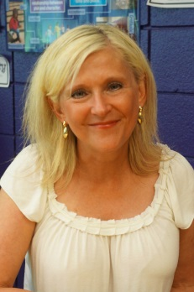
“Firefly Moments”
writer—teacher—speaker
Coleen Paratore

ww.coleenparatore.com

Full-time writer, speaker, and teacher of writing since 2004; author of 19 books.
Whether I am visiting a school with 400 students or teaching a workshop with 14 adults, my goal is to inspire excitement about writing. We travel to the firefly fields inside our own minds and hearts, where our most powerful ideas are sparking, and we write and share, write and share. With each new visit, workshop, or retreat, I add something fresh, always focused on that group. My style is lively, encouraging, and interactive, everyone participates. To book a program, speech, or signing, contact me at www.coleenparatore.com. I look forward to talking with you!
Featured Titles
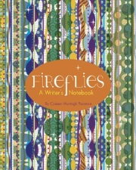 |  |  | FIREFLIES: A Writer’s Notebook (all ages), Little Pickle Press. Encouraging advice, inspiring “spark-starters” and lots of colorful blank pages for “writing without rules.” In bookstores nationwide.  (25% school discount, 50% Title 1 at sales@littlepicklepress.com)  “Sure to be a treasured keepsake.” Author David Lubar  *Mom’s Choice 2014 Gold Award* *Ben Franklin Digital Gold Award for “Catching Fireflies” APP*
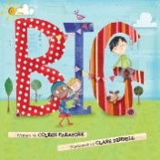 |  |  | BIG (a picture book for all ages), Little Pickle Press.  What does it really mean to be “big?” A character-building conversation starter for school, library, and home; a perfect birthday or graduation gift.  *2013 Gelett Burgess Award* *2013 Nautilus “Better Books for a Better World” Award*  *2013 Mom’s Choice Gold Award* Amazon “Top Ten Picture Book”
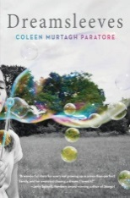 |  |  | DREAMSLEEVES (10-adult), Scholastic Press.  Circa 1970’s, Troy, NY, despite hardships, “A” has big dreams.  “…about the difference between hoping for change and making it happen.” Publisher’s Weekly.  “Every library and bookstore should stock this book and help kids find it.” Carol Chittenden, Eight Cousins Bookstore  “Dreamsleeves reminds us of the pain of innocence lost, the strength of love, and the power of hope.” New York Times bestselling-author, Laurie Halse Anderson; “I loved it!” Newbery Author, Jerry Spinelli
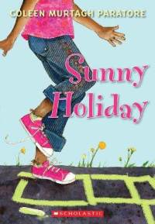 |  |  | SUNNY HOLIDAY and SWEET AND SUNNY (age 8+), Scholastic Press.  A budding poet and politician, Sunny wants to create a new holiday for kids and make life better in her neighborhood. * New York Public Library “Best Books for Reading and Sharing”*  *Bank Street College “Best Children’s Books of the Year”* *American Library Association Notables List*
The Willa Books
EXCITING NEWS!!! Several new Willa books are on the way: 1st release: Summer 2015 (Little Pickle Press)
A voracious reader, journal keeper, and candy eater, a hopeless romantic, community servant, and junior wedding planner at her family’s Cape Cod inn, Willa wants to be an author someday.
 | 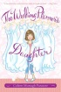 | #1 The Wedding Planner’s Daughter (Simon&Schuster) Moving to Cape Cod with her wedding-planner Mom, Willa plays matchmaker, hoping for a Dad.  ½ million copies sold. |  | 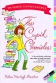 | #2 The Cupid Chronicles (Simon&Schuster)  Willa host dances at her family’s inn to try and save the town library and maybe date “JFK.” | 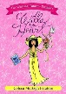 | #3 Willa by Heart (Simon&Schuster)  A mysterious new girl threatens to steal Willa’s lead in “Our Town,” and JKF’s heart as well.
 | 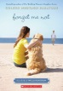 | #4 Forget Me Not (Scholastic Press)  Summer romance, a dog, and a startling surprise. |  | 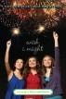 | #5 Wish I Might (Scholastic Press)Mermaid sightings and a newly discovered brother. | 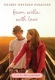 | #6 From Willa, With Love  (Scholastic Press) While JFK is away, another handsome Bramble boy hopes to win Willa’s heart.
For a complete list of my books and upcoming events, workshops and classes please visit www.coleenparatore.com

